Software Design and Engineering Enhancement – Contact Service
Brandon Shank
Date:

Artifact Description
The artifact I worked on for this enhancement is a Contact Service application that I originally built in CS-320. The main purpose of the system is to manage contact records, so users can add, update, look up, and delete contacts. Each contact stores a unique ID, along with a name, phone number, and address.
When I first made this project, it did what it was supposed to do at a basic level, but it didn’t really handle bad input well, and error handling wasn’t very consistent. Because of that, it made sense to use it for this enhancement.

Justification for Inclusion and Enhancements
I chose this artifact because it already showed some core ideas like object-oriented design, working with data, and basic testing. At the same time, it had some obvious weak spots that I could improve, especially around validation and overall reliability.
For the updated version, I focused mostly on making the system more stable and harder to break. Some of the main changes I made were:
Added stronger validation so inputs can’t be blank, too long, or formatted incorrectly. For example, phone numbers now have to be exactly 10 digits.
Prevented duplicate contact IDs and made sure the contact ID can’t be changed after it’s created.
Improved error handling so invalid inputs throw clear and consistent exceptions.
Split responsibilities so the Contact class handles data and validation, and ContactService handles the logic.
Changed the getAllContacts() method so it returns a read-only copy instead of the original data.
Used a HashMap for storing contacts so lookups are fast.
Added more JUnit tests to cover normal cases, edge cases, and bad input.
These changes made the program feel a lot more solid overall, and closer to how something like this would be built outside of a class.

Course Outcomes
This project helped me apply software design ideas in a more real way. I worked on improving how the code is structured, adding validation, and making sure everything was tested properly.
My main goal going into this was to improve validation and testing, and I was able to do that by centralizing validation logic and writing more tests. It showed me how to take an existing project and build on it instead of starting over.

Reflection
One thing that stood out to me during this process was how important it is to validate data early. Before making these changes, it was easy for bad data to get through, but after adding validation and more tests, I felt a lot more confident in how the system behaves.
A challenge I ran into was making changes without breaking existing functionality. At one point, updating validation caused a couple of tests to fail, so I had to go back and figure out what changed. After that, I started making smaller updates and testing more often, which helped a lot.
I also reorganized the project, so things were easier to follow, like separating the model, service, and test code. That made the project feel more structured and easier to work with.
Overall, this project helped me get better at improving existing code, thinking about validation and security, and organizing code in a way that makes sense long term.

Evidence (Screenshots)
Figure 1: Build Success
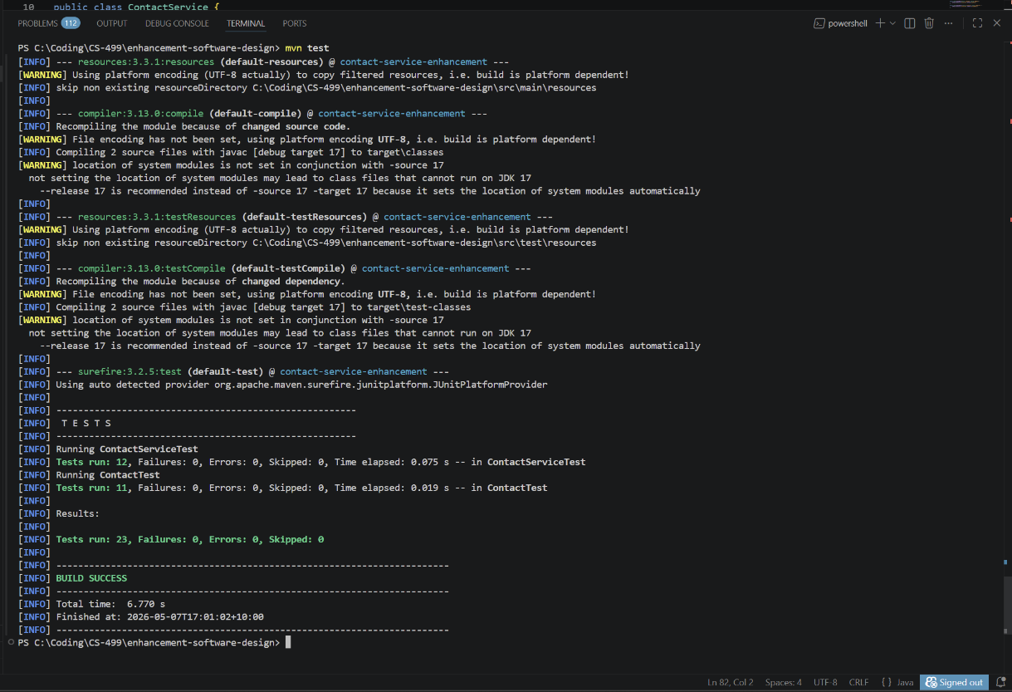
Maven build output showing successful compilation and execution of all unit tests with zero failures, confirming the correctness and stability of the enhanced system.

Figure 2: Tests Running
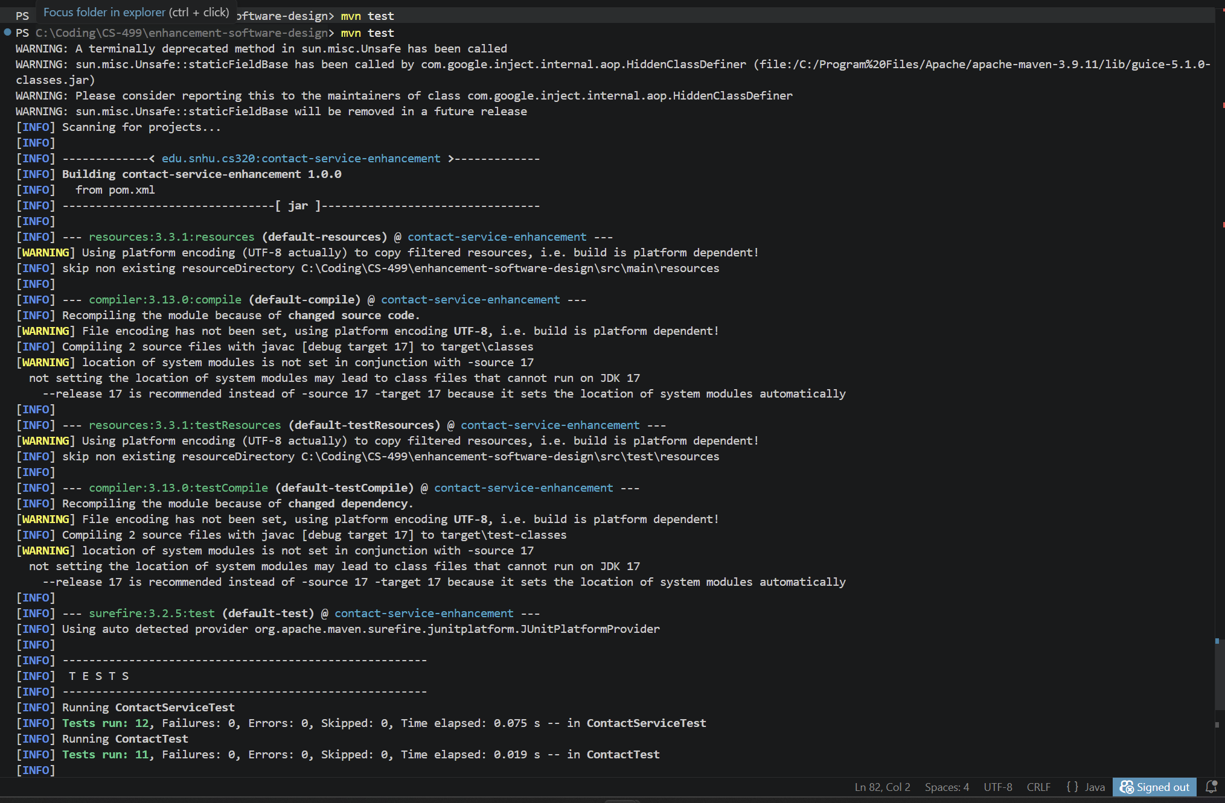
JUnit test execution validating system functionality, including positive, negative, and edge case scenarios to ensure reliability and correctness.

Figure 3: Service Code
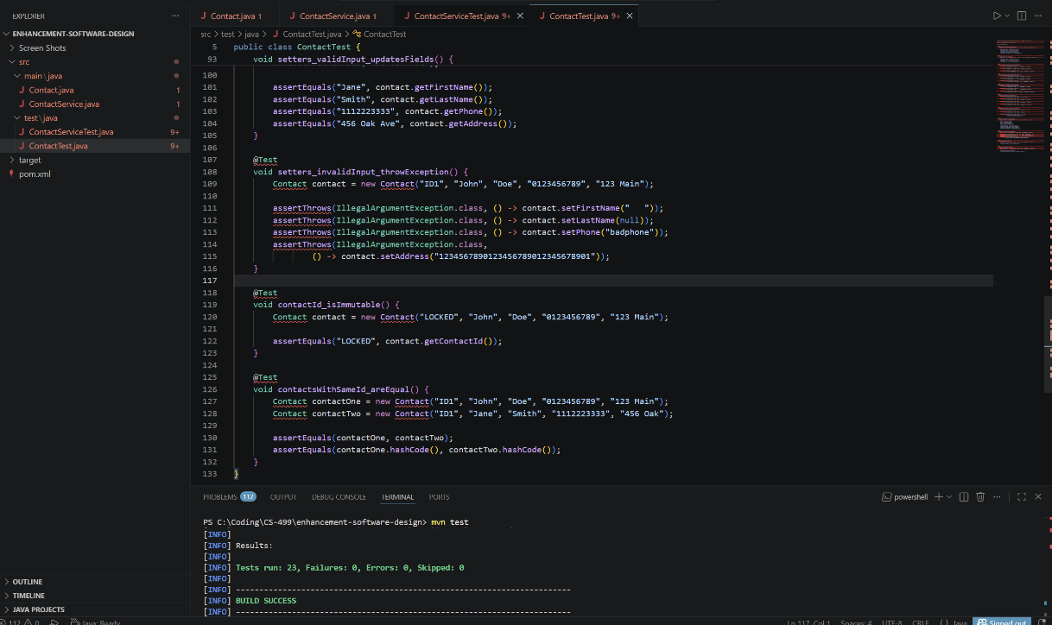
ContactService class implementation demonstrating business logic separation, duplicate ID prevention, and controlled data access through an internal HashMap.

Figure 4: Validation Code 1
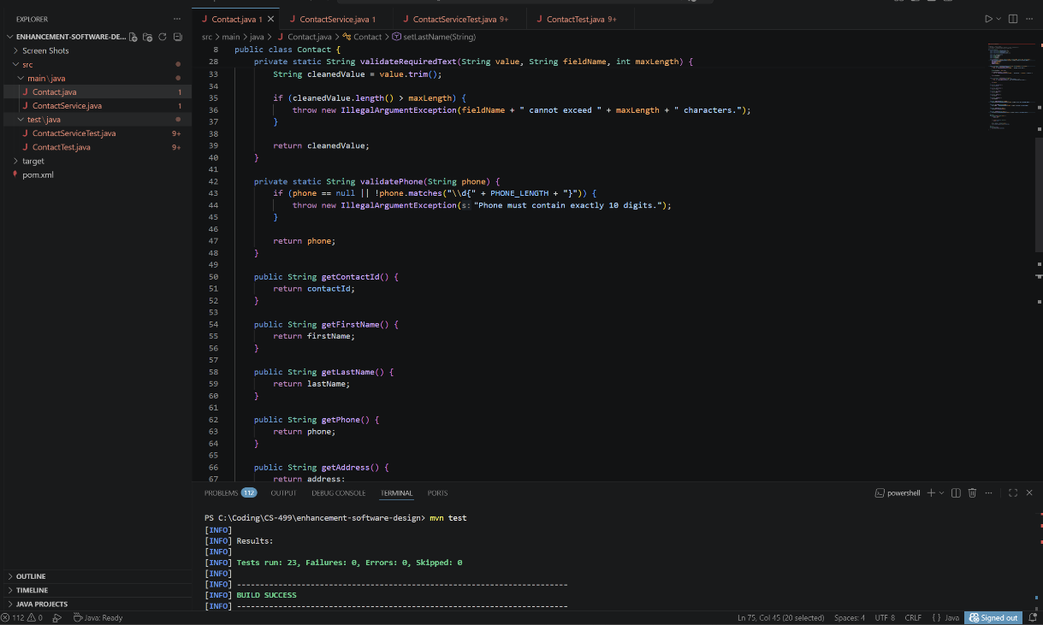
Centralized validation logic ensuring required fields are not null, blank, or exceeding defined length constraints, improving data integrity and security.

Figure 5: Validation Code 2
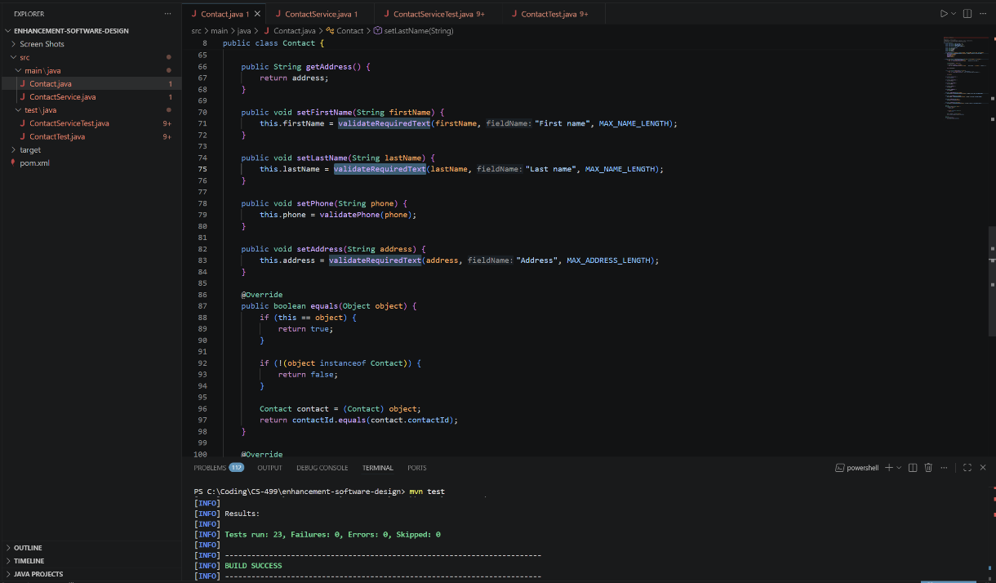
Phone number validation enforcing strict formatting rules (exactly 10 digits), preventing invalid or unsafe input from being processed.

Figure 6: Validation Code 3
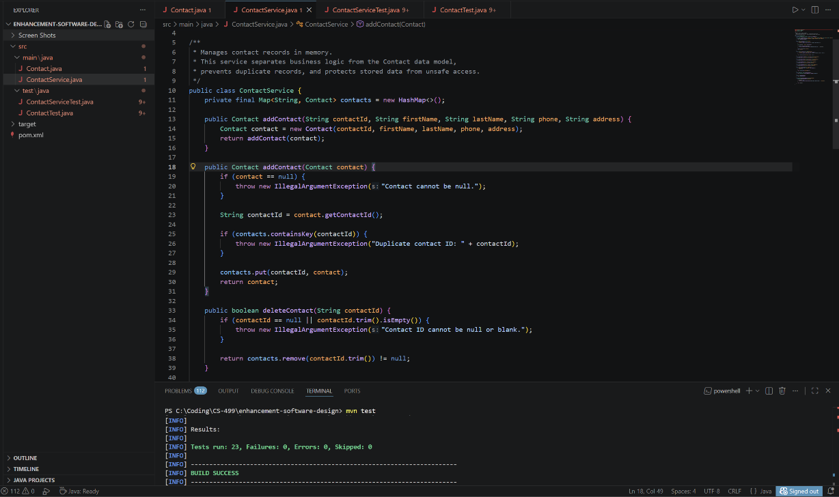
Setter methods applying validation rules before updating object state, ensuring all modifications maintain system constraints.
Figure 7: Validation Code 4
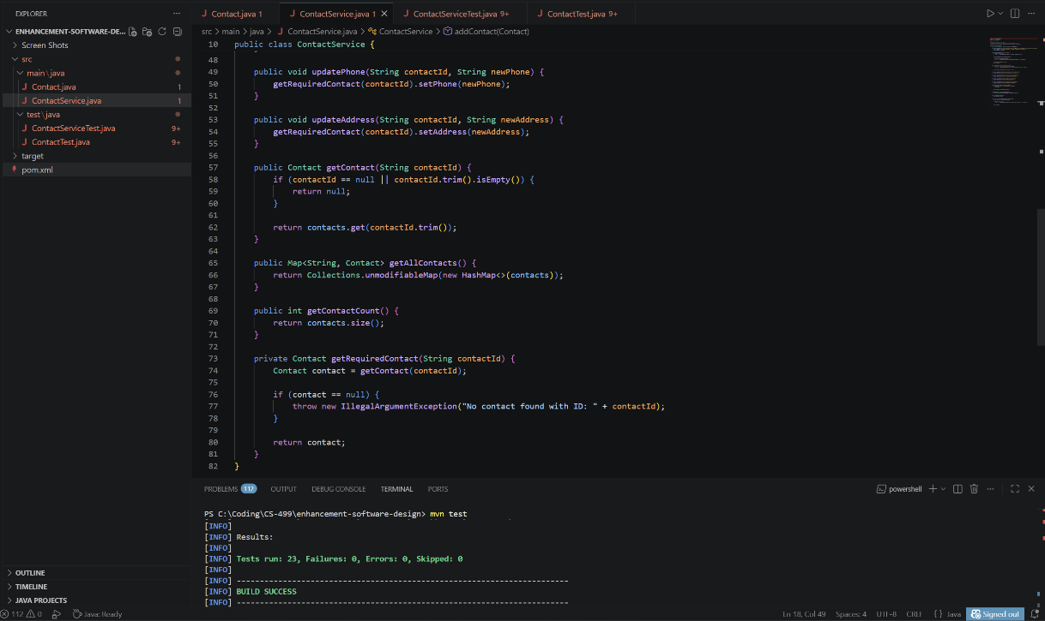
Equality and hashCode implementation based on immutable contact ID, ensuring consistent identity management and preventing logical duplication.

